Uploading Lang file into cx-manager.

* Extract shared en.zip file, here you can find en.json file inside of zip.
* After a login on cx manager you can find a content menu on left side, click on Content to go shared content area.

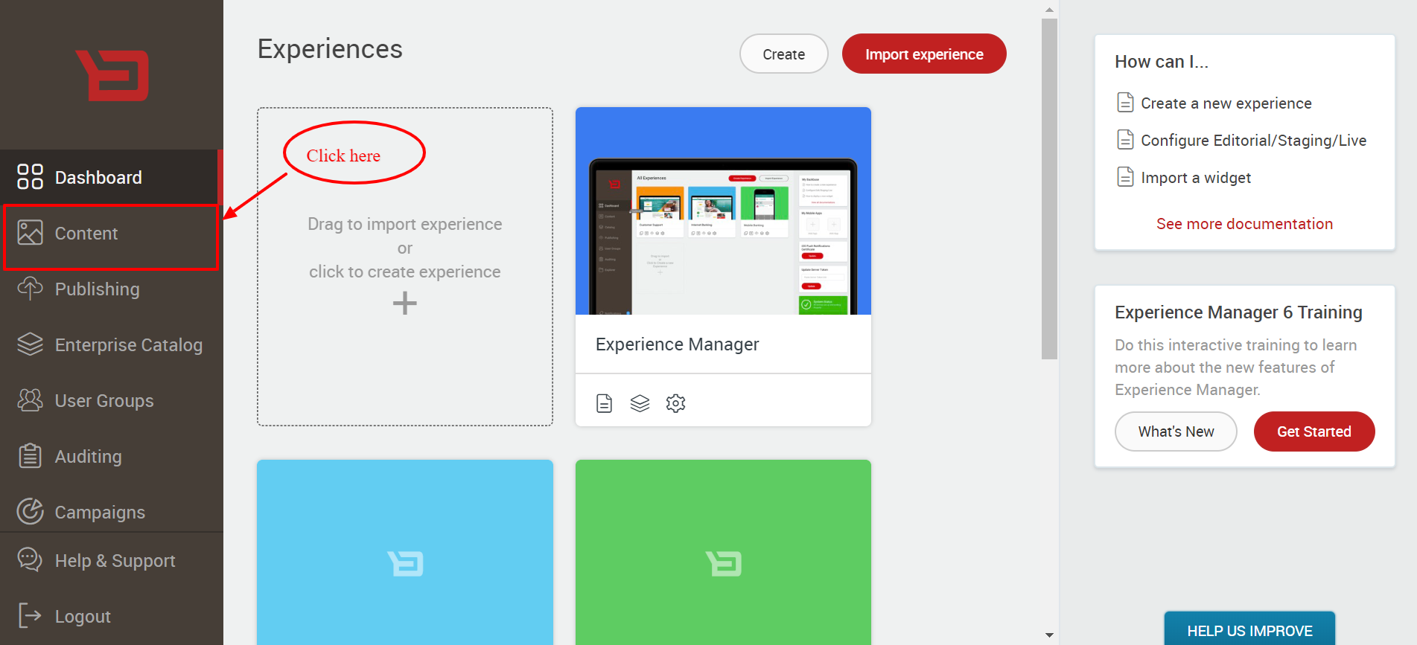

Check inside of share content if **i18n** folder is there then upload en.json file, if folder is not there create **i18n** folder then upload en.json file into **i18n** folder

* If the i18n folder is not created, then refer this

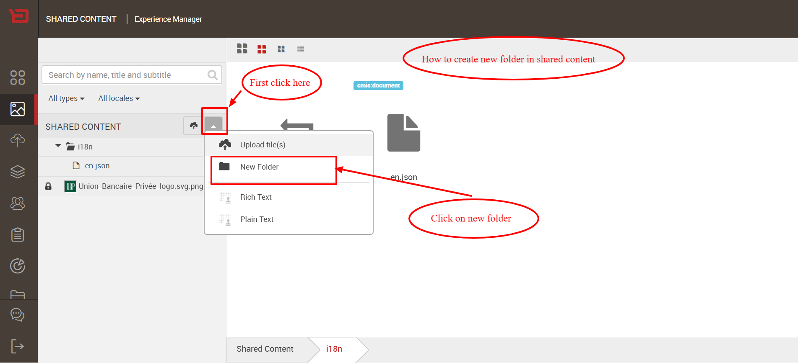

Below screen short for checking **i18n** folder inside of shared content area, as folder is there now we can upload en.json file inside of folder.

* Check **i18n** folder inside of shared content area

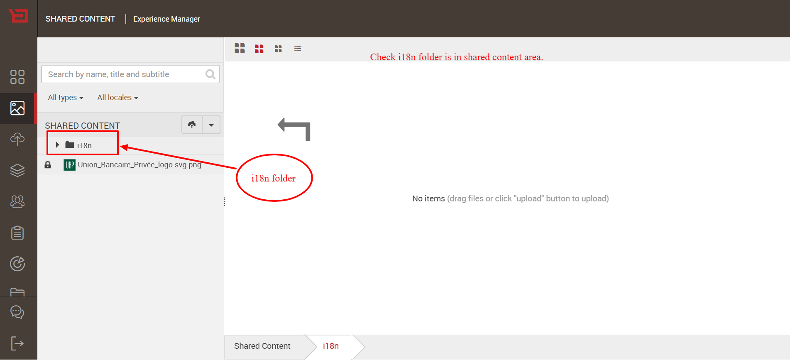

* For upload file (file should be .json ), refer this screenshot.

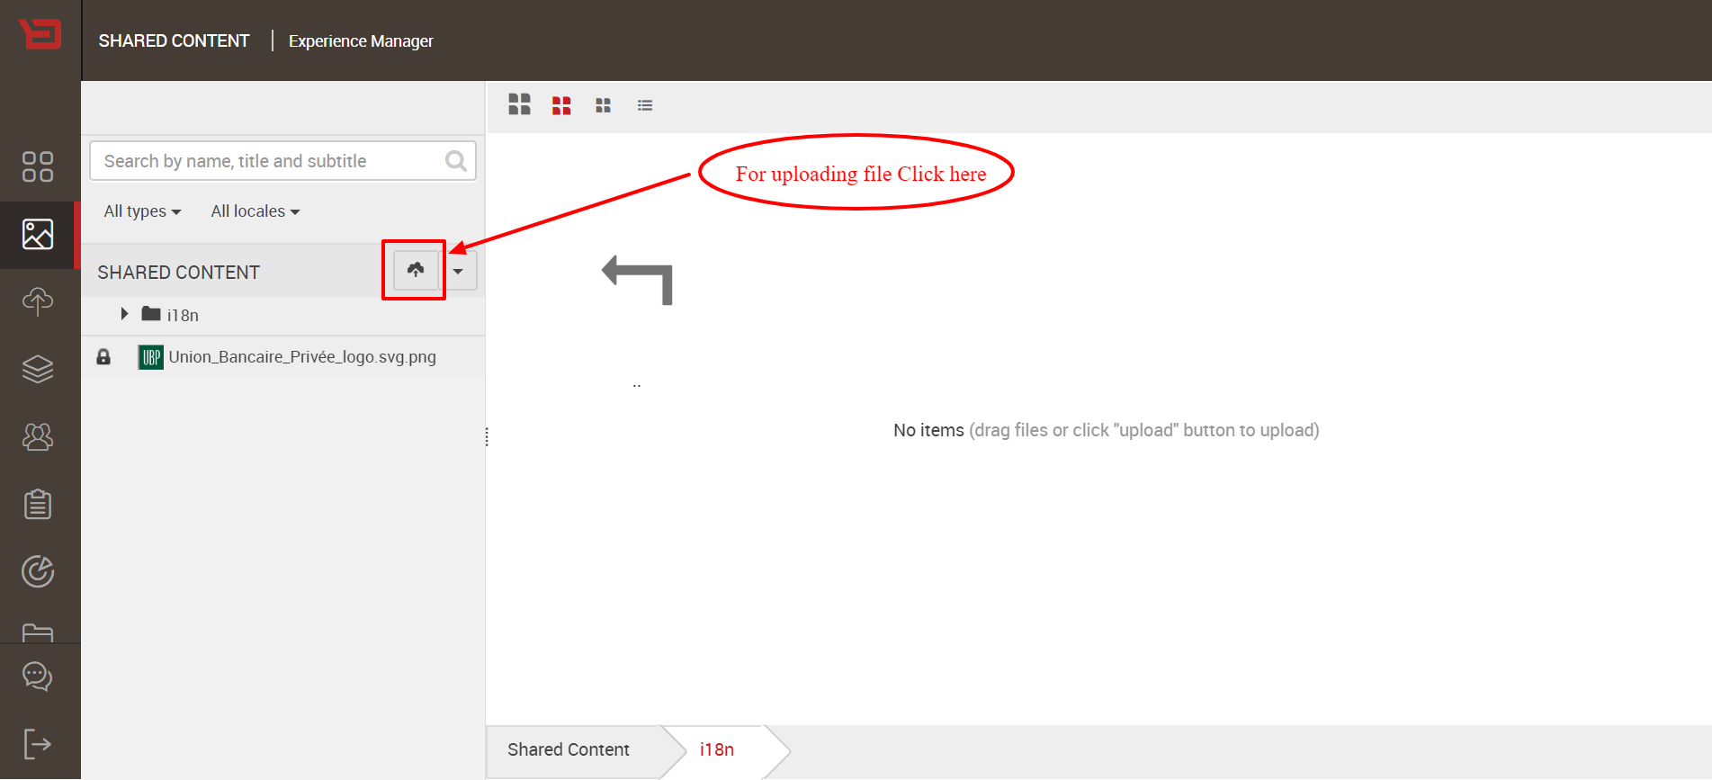

After uploading en.json file it should be look like as below screenshot

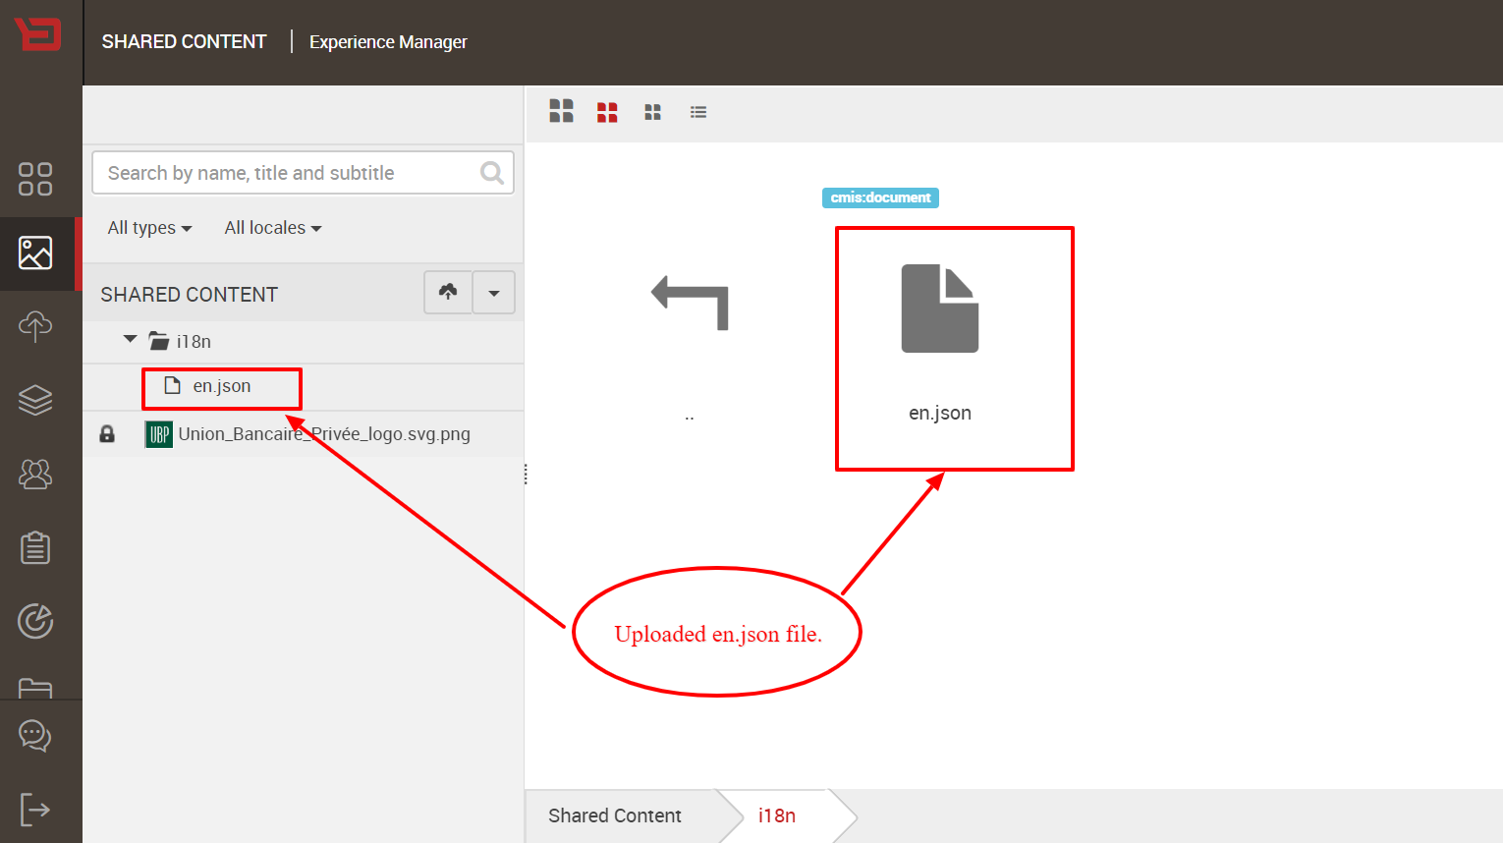

**Updating file for new release:**

If you want to update existing en.json file, with new release refer below screenshot:

How to check file is exist:

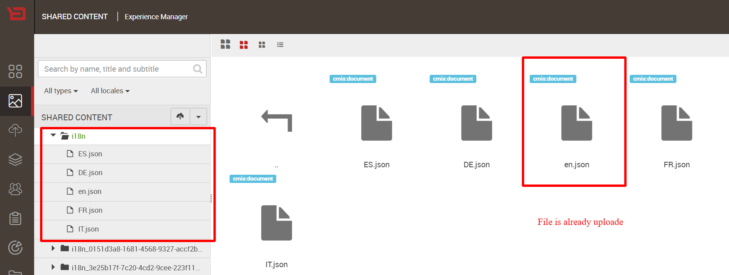

For updating file first we need to delete current version of en.json from shared content

>Below screen short for deleting file from shared content-

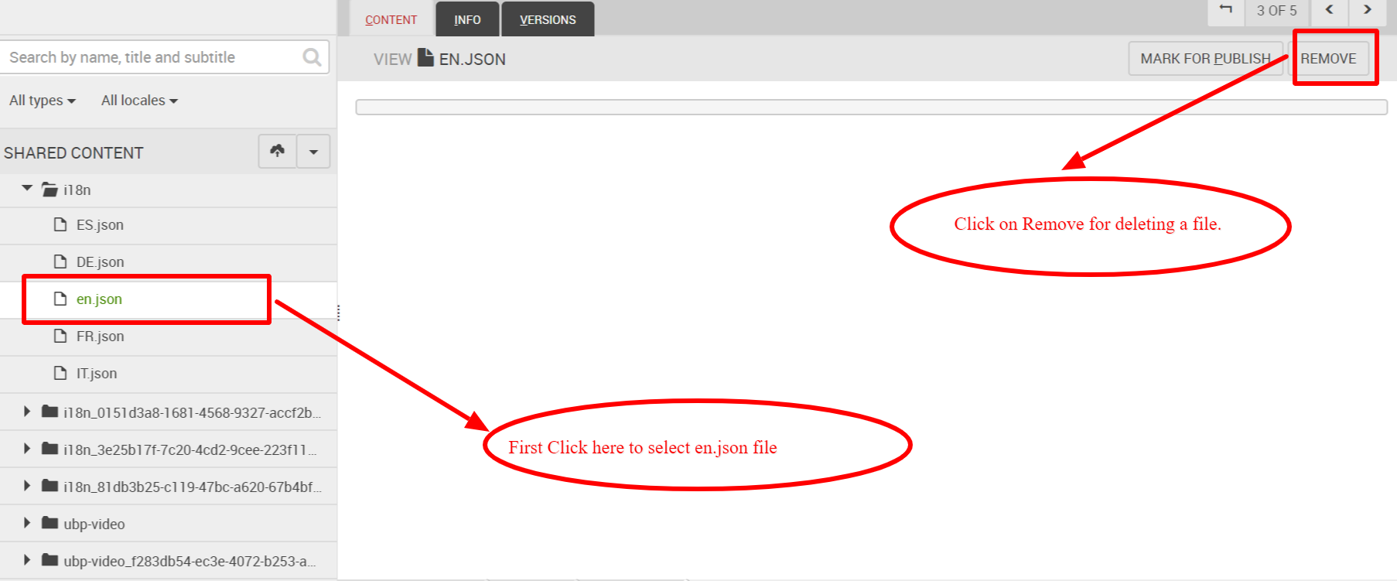

* Re-upload a file (For upload file (file should be .json ), refer this screenshot.) 
* NOTE: if you not able to upload a file you need to refresh a page, its BB issue sometime after deleting a file upload button not works. After refreshing page you can able to upload.

**Last Steps**

After completing above steps, you just need to refresh front end web application for getting the content of uploaded en.json file.

en.json previewed

Here is a preview of en.json file,

